# CS 255 System Design Document Template

## UML Diagrams

### UML Use Case Diagram

*[In Module Six, you were asked to complete a use case diagram based on your system design. If you would like to make any adjustments to your diagram, please do so. Please insert your use case diagram here. Check to make sure that you included appropriate components and symbols and that your design meets the client’s needs.]*

### UML Activity Diagrams

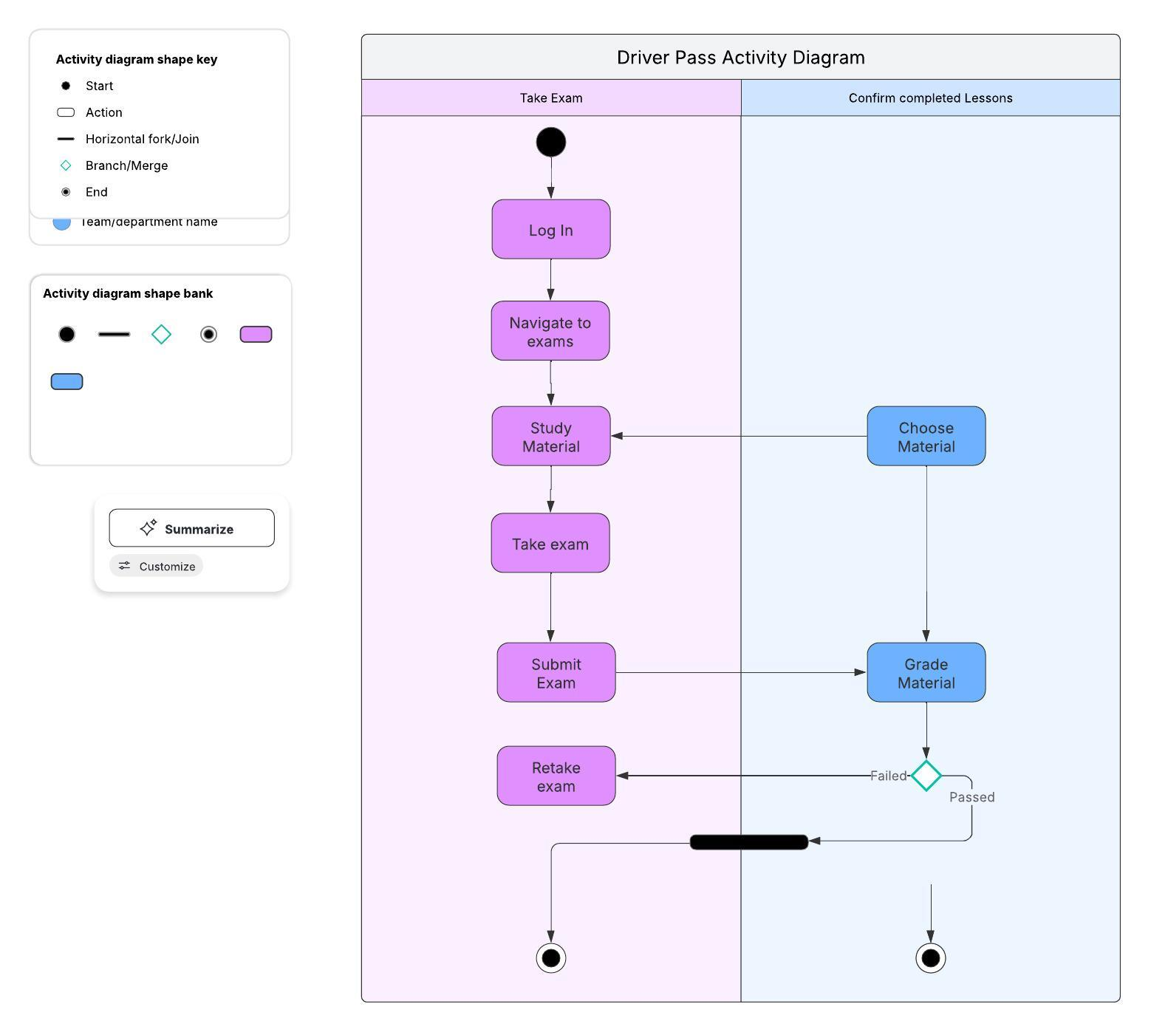

### 

### UML Sequence Diagram

### UML Class Diagram

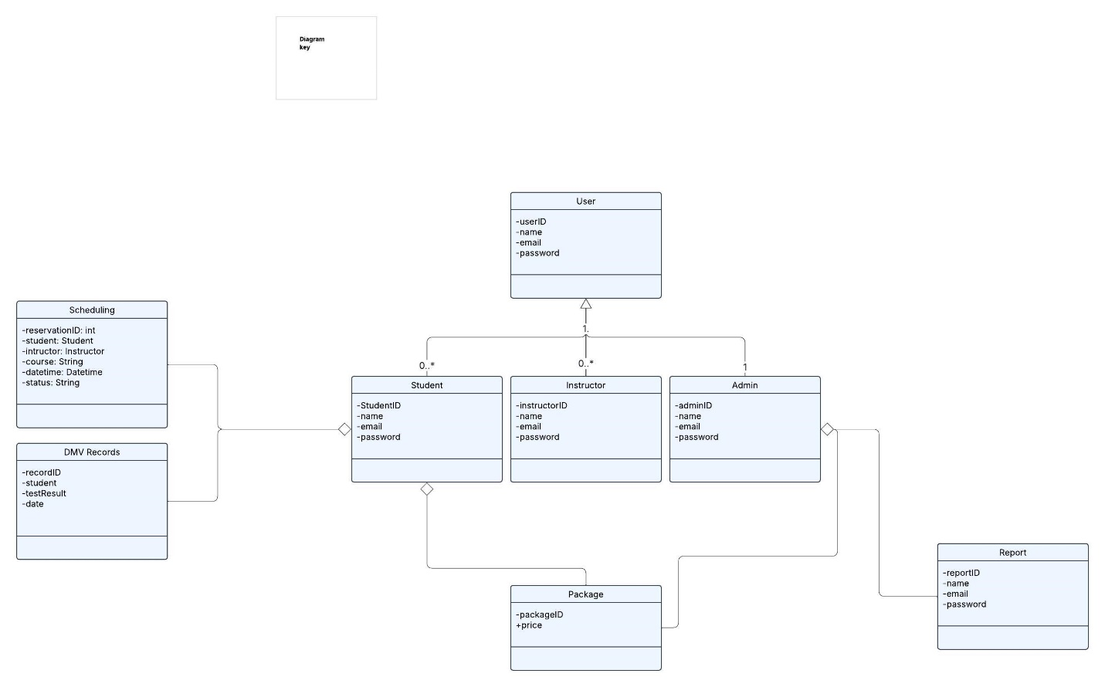

## Technical Requirements

*[Based on the diagrams you have created, describe the technical requirements of your system. These requirements should address the required hardware, software, tools, and infrastructure necessary for your system design.]*

The technical requirements for the DriverPass system involve a variety of hardware, software, tools, and infrastructure designed to deliver strong performance, scalability, and security. DriverPass will operate across Windows, iOS, and Linux operating systems. All data will be stored using a cloud infrastructure to provide secure, scalable, and remote access to information, while also supporting regular backups and reliable file recovery. To achieve 3-second load times, the system will incorporate techniques such as image compression, lazy loading, and browser caching.